# CHAPTER 1

# INTRODUCTION

# PROBLEM DEFINITION

Library is the place where information and books are stored. It is the place where people from all fields uses the books and information required for them. But for that purpose since long time the manual system was followed during operation using the library card. But with the increasing demands of technology in various fields are forcing to stop the manual system in library operation. So to fulfill the increasing demands of the library management software has been developed.

The existing system was a manual system to keep the transaction happened in the library. All the transaction was manually recorded which was time consuming , long and tedious. It was also not reliable. The current system was using the traditional method for daily activities, where the librarian had to handle most of the activities manually as it was taking long time. Here we have tried to implement the manual system into the computer based system as it overcomes most of the flow of the manual system.

The transactions related to Book Purchase, Book Issue and Book Returns are maintained manually at present along with maintaining the accounts of the Students and the Lecturers.

The application should provide quick access to the records maintained and must reveal the important reviews about the System so that the growth can be easily compared and should provide with the various reports showing the related details so that the important decisions could be taken easily.

# PROJECT OVERVIEW

The project titled Library Management System is Library management software for monitoring and controlling the transactions in a library .The project “**Library Management System”** is developed in java, which mainly focuses on basic operations in a library like adding new member, new books, and updating new information, searching books and members and facility to borrow and return books.

“Library Management System” is a windows application written for 32-bit Windows operating systems, designed to help users maintain and organize library. Our software is easy to use for both beginners and advanced users. It features a familiar and well thought-out, an attractive user interface, combined with strong searching Insertion and reporting capabilities. The report generation facility of library system helps to get a good idea of which are the books borrowed by the members, makes users possible to generate reports’ hard copy.

Library management system is a project which aims in developing a computerized system to maintain all the daily work of library This project has many features which are generally not available in normal library management systems. Overall this project of ours is being developed to help the students as well as staff of library to maintain the library in the best way possible and also reduce the human efforts.

# HARDWARE SPECIFICATION

**Processor : Intel core i3 3rd generation**

**RAM : 2 GB**

**Hard Disk : 512GB**

# SOFTWARE SPECIFICATION

Operating System : Windows 7,

Language : Java

Database : MY SQL

# CHAPTER 2

# LITERATURE SURVEY

A Library Management System (LMS) is a tool to help any libraries which are still using the old way to manage their library. The old way like searching for a book using manual work is hassle, fast report generation is not possible, information about issue/return of the books are not properly maintained, no central database can be created as information is not available in database. But by using the LMS, user can overcome all the problems mentioned above. This system can manage all the happenings of the library.

# 2.1 EXISTING SYSTEM

In our existing system, all the transaction of books are done manually, so taking more time for a transaction like borrowing a book or returning a book and also for searching of members and books. Another major disadvantage is that preparing the list of books borrowed and the available books in the library will take more time, currently a one day process for verifying all records. So after conducting the feasibility study we decided to make a computerized library management system.

In manual transaction there is a high possibility of mistakes during the transaction. It is time consuming and manual work is hassle. There are various disadvantages of existing system.

So we can say,

• Fast report generation is not possible

• Tracing a book is difficult

• Information about issue/return of the books is not properly maintained

• No central database can be created as information is not available in database

So after conducting the feasibility study we decided to make the Manual Library management system to be computerized.

# 2.2 PROPOSED SYSTEM

Proposed system is an automated Library Management System. Through our software user can add members, add books, search members, search books, update information, edit information, borrow and return books in quick time. Our proposed system has the following advantages.

• User friendly interface

• Fast access to database

• Less error

• More Storage Capacity

• Search facility

• Quick transaction

All the manual difficulties in managing the Library have been rectified by implementing computerization.

# FUTURE SCOPE OF THE PROJECT

1) User Module (Android App End)In this module student can check availability of the book from the app

The following are the sub module in the user module.

• Student can search for book from his app if it is available or not.

• Student can chat with the other person holding the book

• Reminder for the user to return book before the collection date on his phone.

2) Online use of the library can be good feature for the Library Management system.

3) Advanced fine payment system can be added.

# 2.4 FEASIBILITY STUDY

Whatever we think need not be feasible It is wise to think about the feasibility of any problem we undertake. Feasibility is the study of impact, which happens in the organization by the development of a system. The impact can be either positive or negative. When the positives nominate the negatives, then the system is considered feasible. Here the feasibility study can be performed in two ways such as technical feasibility and Economic Feasibility.

# 2.4.1 TECHNICAL FEASIBILITY

We can strongly says that it is technically feasible, since there will not be much difficulty in getting required resources for the development and maintaining the system as well. All the resources needed for the development of the software as well as the maintenance of the same is available in the organization here we are utilizing the resources which are available already.

# 2.4.2 ECONOMICAL FEASIBILITY

Development of this application is highly economically feasible The organization needed not spend much money for the development of the system already available. The only thing is to be done is making an environment for the development with an effective supervision. If we are doing so, we can attain the maximum usability of the corresponding resources Even after the development, the organization will not be in a condition to invest more in the organization Therefore, the system is economically feasible.

# CHAPTER 3

# SYSTEM ANALYSIS & DESIGN

System Analysis is a detailed study of the various operations performed by a system and their relationships within and outside of the system. Here the key question is what all problems exist in the present system? What must be done to solve the problem? Analysis begins when a user or manager begins a study of the program using existing system.

During analysis, data collected on the various files, decision points and transactions handled by the present system. Training, experience and common sense are required for collection of relevant information needed to develop the system. The success of the system depends largely on how clearly the problem is defined, thoroughly investigated and properly carried out through the choice of solution.

# 3.1 REQUIREMENT SPECIFICATION

LMS is a computerized system which helps user (librarian) to manage the library daily activity in electronic format. It reduces the risk of paper work such as file lost, file damaged and time consuming. It can help user to manage the transaction or record more effectively and time saving. LMS needs various system requirements.

# 3.2 SYSTEM REQUIREMENTS

# 3.2.1 NON FUNCTIONAL REQUIREMENTS

**EFFICIENCY REQUIREMENT**

When a library management system will be implemented user will easily access library as searching and book transaction will be very faster

**RELIABILITY REQUIREMENT**

The system should accurately perform member registration, member validation, report generation, book transaction and search.

**USABILITY REQUIREMENT**

The system is designed for a user friendly environment so that student and staff of library can perform the various tasks easily and in effective way.

**IMPLEMENTATION REQUIREMENTS**

In implementing whole system it uses JAVA in front end with sql as server side scripting language which will be used for database connectivity and the backend i.e. the database part is developed using mysql

# 3.2.2 FUNCTIONA L REQUIREMENTS

**USER INTERFACE**

This feature used by the user to run the program for this purpose a desktop application will be provided.

# ADD NEW STUDENT

# This feature allows to add new student in database.

# ADD NEW BOOK

# This feature allows to add new books to the library.

# DESCRIPTION OF FEATURE

# This feature is found in book maintenance part we can search book based on book id book name.

# ISSUE BOOKS AND RETURN BOOKS

This feature allows issuing and returning books.

# 3.3 SOFTWARE AND HARDWARE REQUIREMENTS

# 3.3.1 SOFTWARE REQUIREMENTS

• **Operating system**- Windows 7 is used as the operating system as it is stable and supports more features and is more user friendly.

• **Database MYSQL**- MYSQL is used as database as it easy to maintain and retrieve records by simple queries which are in English language which are easy to understand and easy to write.

• **Programming language**- **JAVA**  is used to write the whole code and develop the project**.**

# 3.3.2 HARDWARE REQUIREMENTS

# • Processor- Intel core i5 3rd generation is used as a processor because it is fast than other processors an provide reliable and stable and we can run our pc for longtime. By using this processor we can keep on developing our project without any worries.

# • RAM- Ram 4 gb is used as it will provide fast reading and writing capabilities

# and will in turn support in processing.

# 3.4 FLOW CHART & DFDs

# CHAPTER 4

# RESULTS AND OUTPUTS

# 

The system after careful analysis has been identified to be presented with the following functions:

**USER INTERFACE**

This feature provides an interface to interact with the user.

# DESCRIPTION OF FEATURE

This feature is found in book maintenance part we can search book based on book id book name

# ISSUE BOOKS AND RETURN BOOKS

This feature allows issuing and returning books.

# USER INTERFACE (Snapshots)

# Fig 4.1- Welcome page of LMS

# 

# Fig 4.2- Add a new book

# 

# Fig 4.3- Book details

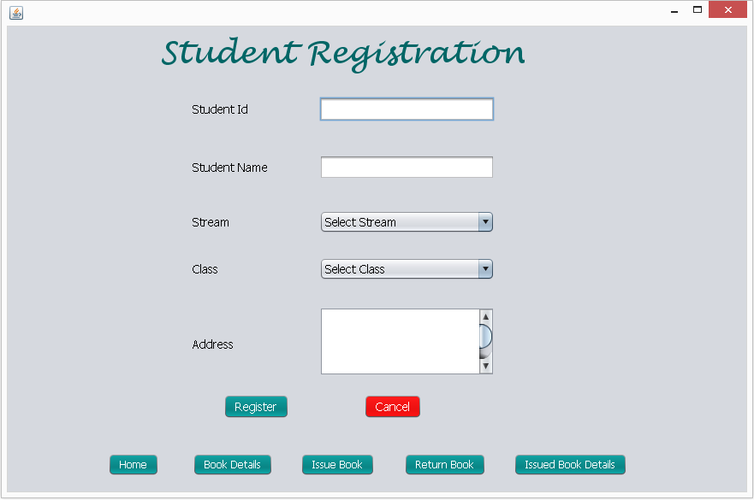

**Fig 4.4-** Student Registration

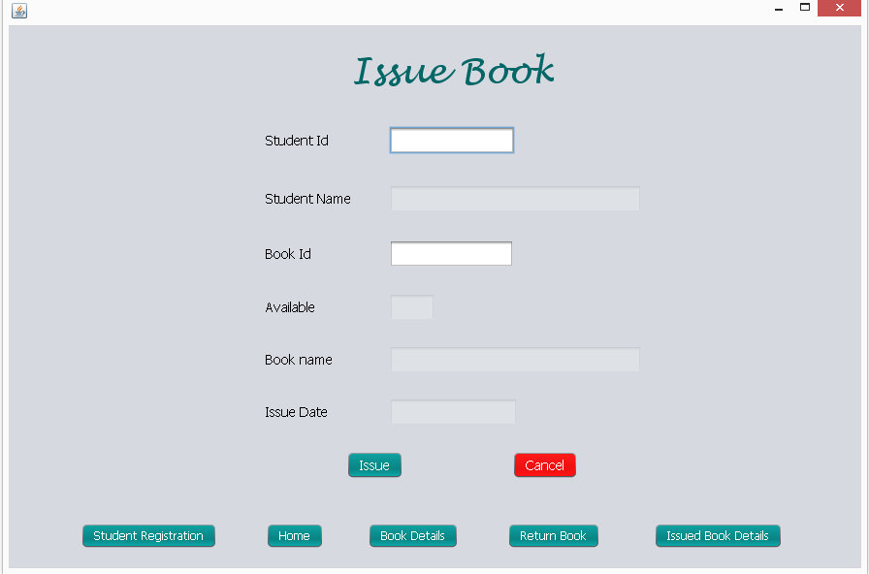

**Fig 4.5-** Issue Book

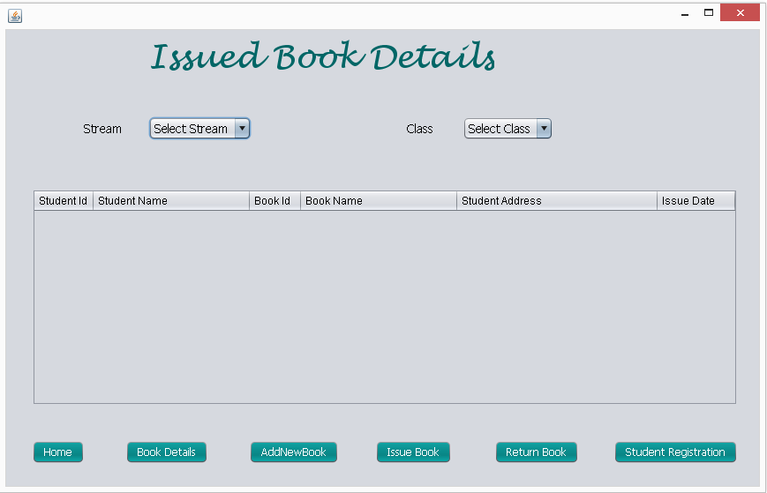

**Fig 4.6-** Issued book details

# 

# CHAPTER 5

# CONCLUISON AND FUTURE IMPROVEMENT

It has been a great pleasure for me to work on this exciting and challenging project. This project proved good for me as it provided practical knowledge of not only programming in JAVA and web based application and no some extent Windows Application and SQL Server, but also about all handling procedure related with “**LMS**”. It also provides knowledge about the latest technology used in developing application and client server technology that will be great demand in future. This will provide better opportunities and guidance in future in developing projects independently. In this project development process, I have learnt a lot of new knowledge and programming code from this project. Besides that, there are also some problems that appears as biggest challenge during the development process. During system design stages, the problem appears on how to construct the Entity Relationship diagram and Data Flow Diagram. Assignments and studies materials in Diploma level studies materials are referred back. Some sample diagram and researches are done via Internet for more reference.

# FUTURE IMPROVEMENT

# For further improvement there can be various improvements in Library management system. Some of the feature are as,

# • User Module (Android App End) In this module student can check availability of the book from the app.

# • Moreover, it is just a beginning; further the system may be utilized in various other types of tasks.

# • All the activities which are not done through this system can be added, so that the ACMS provides each and every functionality of the organization.

• Online use of the library can be good feature for the Library Management system.

# 

# REFERENCES

# 

# APPENDICES

# 

# Snapshots of LMS

# 

# Fig 7.1- To add a new book

# 

# 

# Fig 7.2- Book Details

# 

# Fig 7.3- Student Registration

# 

# Fig 7.4- To issue book

# 

# Fig 7.5- Issued Book Details

# 

# Fig 7.6- Return Book.